Instrument Test Plan

Summary
There are currently three instruments within the orbit system, which are connected to a master SIU device. The master SIU acts as the local instrument master control, sending instructions and receiving data via the OmmoCom network. The three current instruments are:
- Instrument tracker.
- Patient reference.
- Pointer.

Scope
The purpose for this test plan is to perform basic functional testing of the hardware systems used in the instrument accessories. Testing of absolute accuracy, precision or range of the sensors is out of scope of this document.

The Top-Level System
Each of these of the instruments have a different numbers and types of sensors that need to be accessed via the OmmoCom interface. The PC will communicate to the OmmoCom master and access the slave test modes. During the development process, the PC will send UART commands to an ST Micro MCU that will behave as a simplified OmmoCom master. UART scripts will be developed to minimize the amount of manual processing that is required to test the system.
It is anticipated that for the production units, the PC will use the Ommo CNCTestApp to send commands over USB to a master SIU. The master SIU will then control the commands over the OmmoCom interface and execute test commands and pass result data to the PC application.
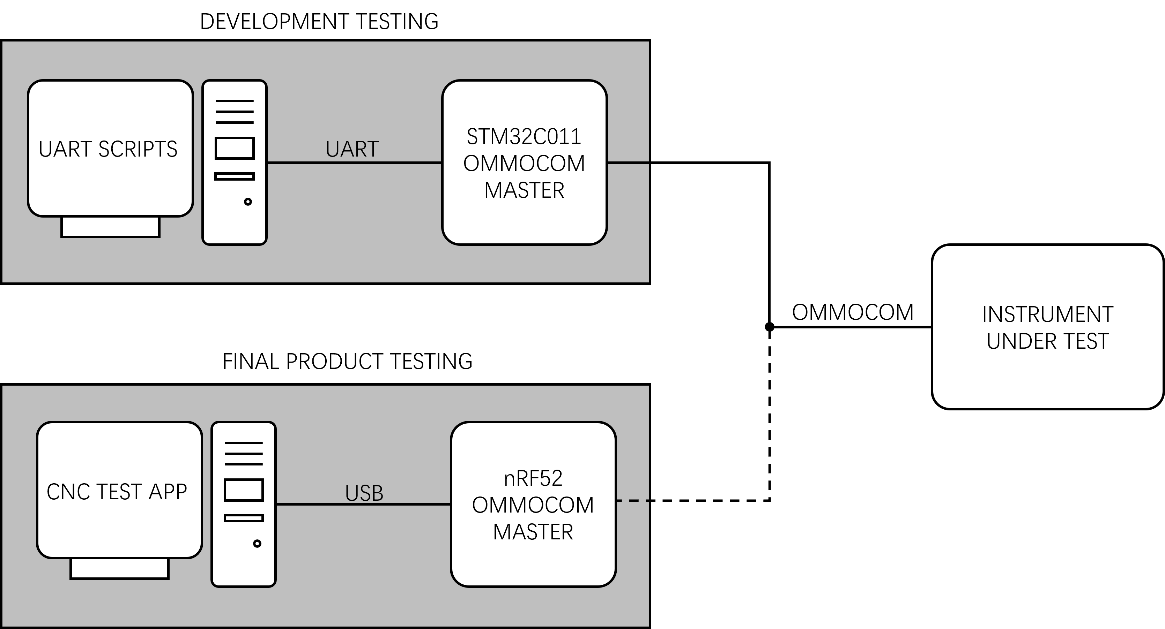

Instrument Types
There are currently 3 different instrument types that require testing.

Instrument Tracker
This is the simplest instrument type; it only has a virtual EEPROM operating inside the STM32C011 MCU.
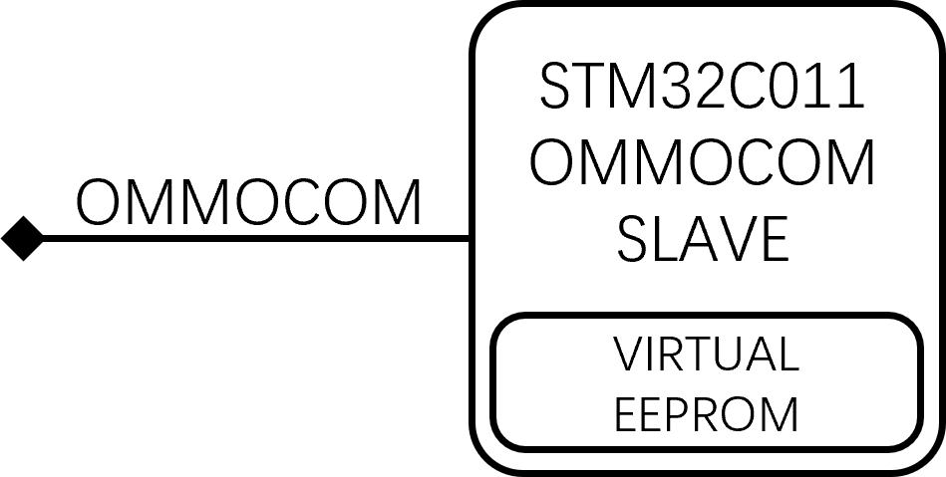

Patient Reference
This instrument has the embedded virtual EEPROM, in addition to 2 magnetometers, an IMU and a temperature sensor. The test mode needs to access sensors via I2C and SPI to test the attached sensors.
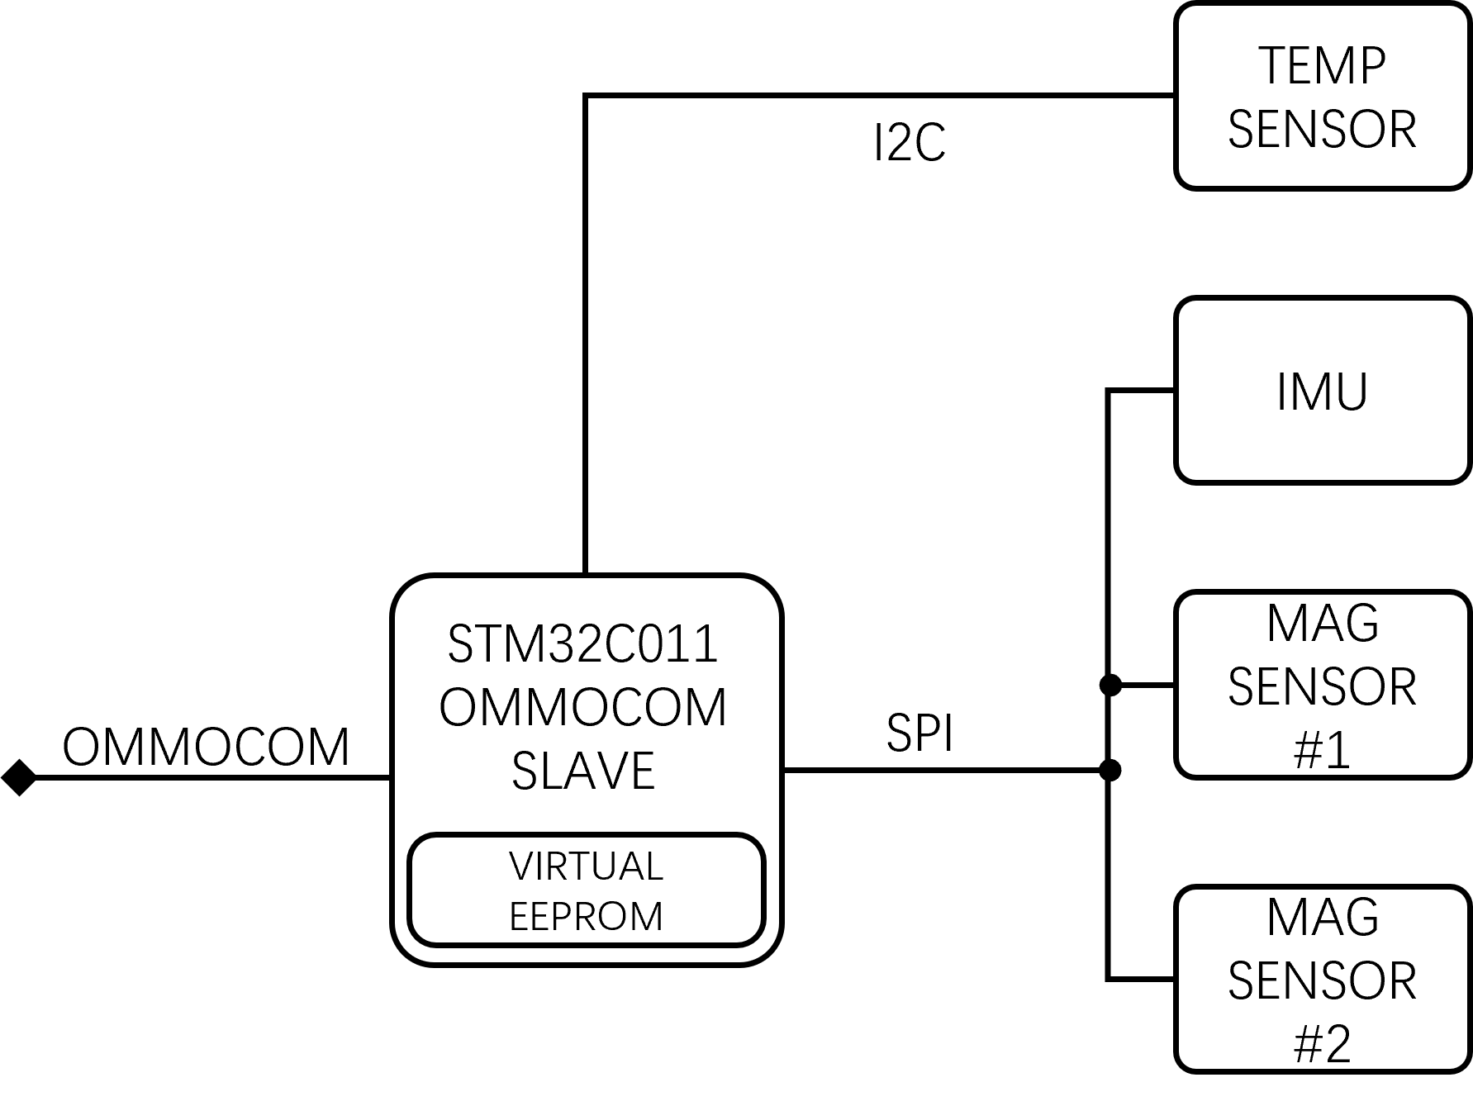

Pointer
This is the most complex of the current instrument types. In addition to the hardware of the patient reference, there is also the following hardware:
- 5-way switch, connected to an ADC for sensing the buttons as levels.
- A second OmmoCom slave MCU.
- An additional magnetometer connected to the second slave MCU via SPI.

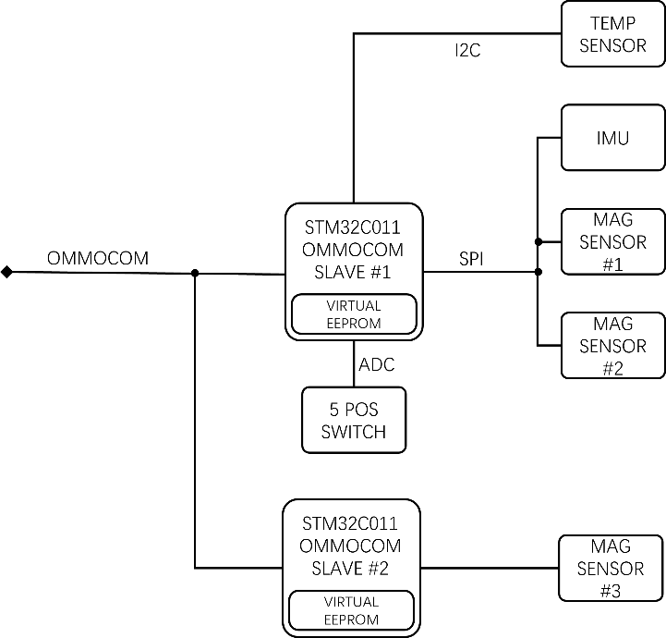

Sensor Testing

Virtual EEPROM
The virtual EEPROM will be tested by writing a series of 2K byte test images to the device, and then reading back the contents of the device after writing. The power will be cycled between the writing and reading steps. Test files will use different bit combinations to ensure that all memory is accessible and writable, examples of test files are:
- All ones.
- All zeros.
- Byte-wise checkerboard.
- Inverse byte-wise checkerboard.
- Bit-wise checkerboard.
- Inverse bits-wise checkerboard.

Temperature Sensor
Equipment: Thermocouple based digital thermometer.
The temperature sensor will be read at ambient room temperature and the values received will be decoded and checked that they are in the correct range of expected values. The sensor can then be warmed with a light application of a hot air gun, the values should be read again and the values obtained decoded and checked that the sensor continues to have approximately correct readings.
During the process, a thermocouple probe will be attached to the body of the sensor to act as a reference to check the sensor readings against.

3 axis Magnetometers
Equipment: Orbit basestation, EMC test board.
The scope of this test is to check that in the presence of a stationary magnetic field, the X,Z & Z values of all of the magnetometers remain relatively static (allowing for noise, ambient fluctuations, etc). Once this baseline of a static reading has been established, a basestation placed in nearby proximity will switched on to generate a local magnetic disturbance. The magnetometers will then be sampled and the resulting data checked to see if an alternating magnetic field is detected. Data should be logged so that if can then be checked that the alternating magnetic fields are at the correct rotational frequency that matches the basestation rotation rate.
During the test, the basestation and the instrument must be mounted to an Ommo standard EMC test base and the devices secured to prevent any physical movement.

Condition | Sensor Data Range Limits
Static magnetic field | <+/- TBD
Dynamic magnetic field | >+/-TBD
Alternating frequency | 15 Hz +/- 3 Hz  30 Hz +/- 6 Hz

IMU
The IMU has a 3-axis accelerometer and a 3-axis gyroscope. All channels of both sensors will be tested. The test mode for this will entail logging data from the X,Y and Z axis of both sensor types.
It is essential that orientation of the sensor is carefully checked before performing this test. The instrument needs to be translated in the X, Y and Z axis separately and in both the positive and negative directions of each axis. The logged data can then be checked manually for acceleration occurring in the correct axis and in the correct direction.
The gyroscope will need to be tested by rotating the device around each of the axis in turn and checking that the channel with the dominant perturbations is correct.
The axis reference for the IMU is shown below.
